Qatar relies on a flexible choice of fuels
New triplex pump drive unit will also power natural gas tankers with LNG in the future
Highly poisonous heavy oil, a waste product of petroleum refineries, is still blown through the funnels of tankers into the air without being filtered. To reduce the burden on the environment, especially near the coast, while being able to react better to price fluctuations, Qatar wants to arrange the future operation of its entire LNG fleet on a flexible basis. The dual-fuel engines that MAN Diesel & Turbo developed for this purpose can optionally be operated with heavy oil or with the liquefied natural gas in the hold. To do this, the boil-off gases are reliquefied under high pressure and injected into the ship's engine. Since ships are always operating and only brought into dry dock for maintenance once in five years, the high-performance pumps used for this purpose must be extremely robust and temperature-resistant. One of the favorites for the supply of these high-performance pumps is Cryostar SAS, a specialist in cryogenic gases. As a partner of this French manufacturer, Lewa GmbH was entrusted with the development of a new drive unit that meets the strict requirements for this application.

Heavy oil is easily obtained, difficult to burn, and can be fed into the engine at low pressure. When the large transport ships of the Q-flex and Q-max LNG fleet were built nine years ago, the decision was therefore made to use slow-running diesel engines, since these are also thermally more efficient than steam turbines and burn less fuel. But it is foreseeable that tankers like those in Qatar will have to convert to other fuels in the future for environmental reasons – at least near the coast. Transport ships with dual-fuel engines like the ones the Emirate wants to use, however, are new territory for everyone involved. Many ship-owners found the technical risk too high, since LNG can be transported safely in the liquid state only at very low temperatures. However, the option of using on-board natural gas as a fuel is also becoming more attractive because engine efficiency is improved in comparison with heavy oil.

Using boil-off gases
The challenge for the ships is that liquefied gas warms up during travel, partly converting back into its gaseous state, meaning that its volume grows by a factor of 600 and the pressure in the storage tanks rises. Venting these boil-off gases harms the environment and reduces the profits of both the producers and the charter companies. Instead, in the Q-flex and Q-max LNG fleet, they are therefore reliquefied. This yielded the idea of making the gas available to operate the ship. Additional equipment will therefore be provided to make the fleet flexible in its choice of fuel. This allows a reaction to the current prices in the specific export country: If gas is trading high there, it's better to sell it than to burn it in the ships’ engine . But in the opposite case, it pays to operate the ship with LNG. But since the gas is extremely explosive, absolutely tight special equipment is needed that can withstand both the temperatures and the high pressures.

Special equipment: High-performance triplex drive unit
With the Triplex pumps that Cryostar and Lewa developed together, both companies are ideally prepared for this new application. The French company is a pioneer in this area and developed the pump heads to meet the requirements for cryogenic liquefied gases. The corresponding G3M triplex drive unit is a special-order production of the Leonberg-headquartered system builder. "Cryostar has the know-how needed to work with cryogenic gases at temperatures ranging from -160 to -200 °C, while we have the robust, low-maintenance drive unit technology needed for long-term operation," explains Thomas Bökenbrink, product manager at Lewa, in reference to the synergy between the two companies. With a rod force of 125 kN, the G3M transforms the rotary movement into an oscillating movement, achieving a maximum power of 160 kW. The development also closes a gap in the manufacturer's portfolio. "This is an intermediate size with a 120 mm stroke length, and we see additional market potential for it," explains Bökenbrink.
In this family of Triplex drives, which currently includes seven sizes, the G3M is thus in the middle. The G3S, with a stroke length of 60 mm and a maximum piston rod thrust of 35 kN, is the smallest model, while the G3T with its stroke length of 270 mm and 300 kN rod thrust is currently the largest drive.

Trouble-free open for over 40,000 hours
During the development of the new drive, Lewa could make use of experience gained with the sister models of the G3M. These are used, for example, in injection pumps for monoethylene glycol (MEG) and methanol in the oil and gas industry, as well as in the process industry in reactor pumps for vinyl acetate and the metering of ammonia under high pressure. "Our Triplex drives are also used as injection pumps for suspensions in wet oxidation in the process industry, and for the injection of condensate in the oil and gas industry," says Bökenbrink, listing additional application areas. Triplex drives are the basis for oscillating positive-displacement pumps in these different application areas, and have demonstrated their toughness for decades in a wide variety of climate zones, including the Arctic, the tropics, and deserts. The drives are even used successfully in the offshore sector.

The G3M combines the positive characteristics of all the models into one package. They are all characterized by a constant stroke length, and are built with an integrated worm gear notable for its high load capacity. The compact construction is achieved with a monoblock drive housing, to which the motor is flanged in a vertical orientation. This construction allows the number of bearings and seals to be reduced to an absolute minimum. The connection to the motor is carried out using a proven coupling with a flexible intermediate element. The perfect phase offset between the three pistons is achieved by using a single, massive crankshaft with three crank bends. This means that the shaft only needs two roller bearings, while the bearings for the connecting rod are plain bearings to ensure better damping of dynamic loads. To avoid an error-prone external lubricant supply, the lubrication of all moving parts is ensured with an oil bath or submersion lubrication.

All components of the drives are designed for long-term load, making trouble-free operation of over 40,000 hours possible. "The flow rate in the G3M, just as in all the Triplex pumps, is controlled with a frequency converter that uses variation in motor speed to regulate the number of strokes per minute and therefore the flow rate," explains Bökenbrink.

The first prototype from Cryostar and Lewa is currently in the testing phase. If the results of these tests and the first trips under load come out positive, the system will be tested on a ship under real conditions. The costs for the retooling are estimated to be about $15 million US per ship, with the total order volume for all 45 ships in the Q-flex and Q-max fleet coming to $700 million.

The French technology company Cryostar SAS was founded in 1966 and is a world leading manufacturer of cryogenic and refrigeration systems. The hundred-percent subsidiary of the Linde Group specializes in equipment and provision of technical knowledge in the areas of industrial gas, liquefied natural gas (LNG), hydrocarbons, and environmentally friendly energy. Cryostar supplies pumps, turbines, compressors, heat exchangers, filling stations, natural gas liquefaction and natural gas regasification systems and power plants to international customers with the strictest of requirements. The company employs about 450 people and had turnover of about 200 million Euros at last report, 90 percent of which were in export business.

LEWA GmbH was founded in 1952 as a family company by Herbert Ott and Rudolf Schestag, and today is the world's leading manufacturer of metering and process diaphragm pumps as well as complete metering systems for process technology. The company, headquartered in Leonberg, Germany, has developed over just a few decades into an international group, and its position in the world market was further strengthened by its integration into the Japanese Nikkiso Co. Ltd. in 2009. As a researching and productive company, LEWA develops technologies and works out solutions for a wide variety of its customers' applications. Products are primarily used in the oil and gas industry, in the area of gas odorization, refineries, and petrochemistry, but also in the manufacture of plastics, detergents, and cleaning agents. Additional application areas can be found in chemistry, the cosmetics industry, in pharmaceutical and biotechnology, in the food and beverage sector, and in power supply. LEWA currently has approximately 840 employees and has 16 subsidiaries worldwide as well as representatives and sales offices in over 80 countries.

Images:
Image ID: LNG.jpg
Caption: Qatar wants to put the operation of its entire LNG fleet on a flexible basis in the future. The dual-fuel engines developed for this purpose can optionally be operated with heavy oil or with the liquefied natural gas in the hold.
Source: Qatargas Operating Company Limited

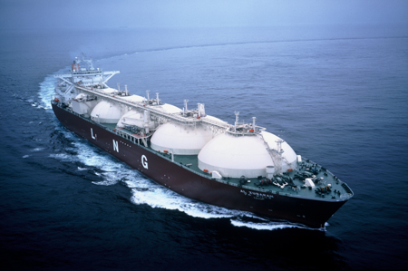

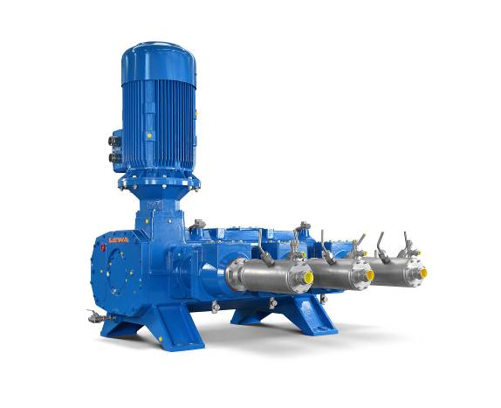
Image ID: G3M.jpg
Caption: The triplex G3M drive unit is a special-order production of the Leonberg-headquartered system builder Lewa. This is a robust, low-maintenance intermediate size specifically designed for long-term operation on natural gas tankers.
Source: Lewa GmbH

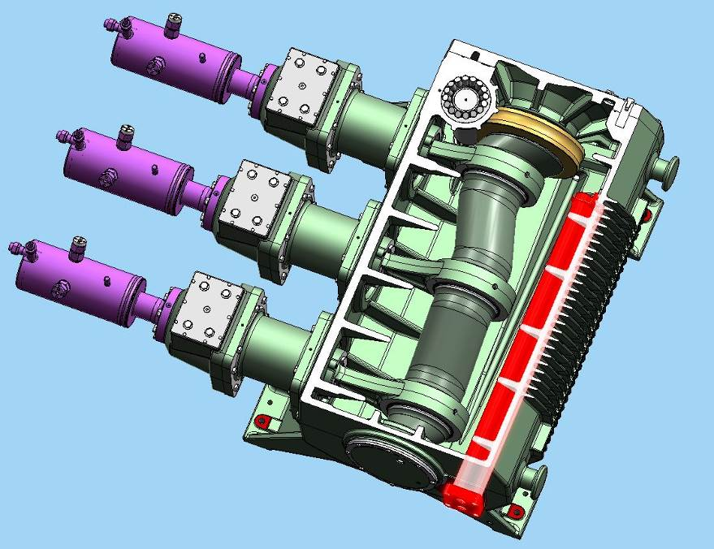
Image ID: G3M_CAD_Cross section of drive housing.jpg
Caption: The perfect phase offset between the three pistons is achieved by using a single, massive crankshaft with three crank bends. All components are designed for long-term load, making trouble-free operation of over 40,000 hours possible.
Source: Lewa GmbH

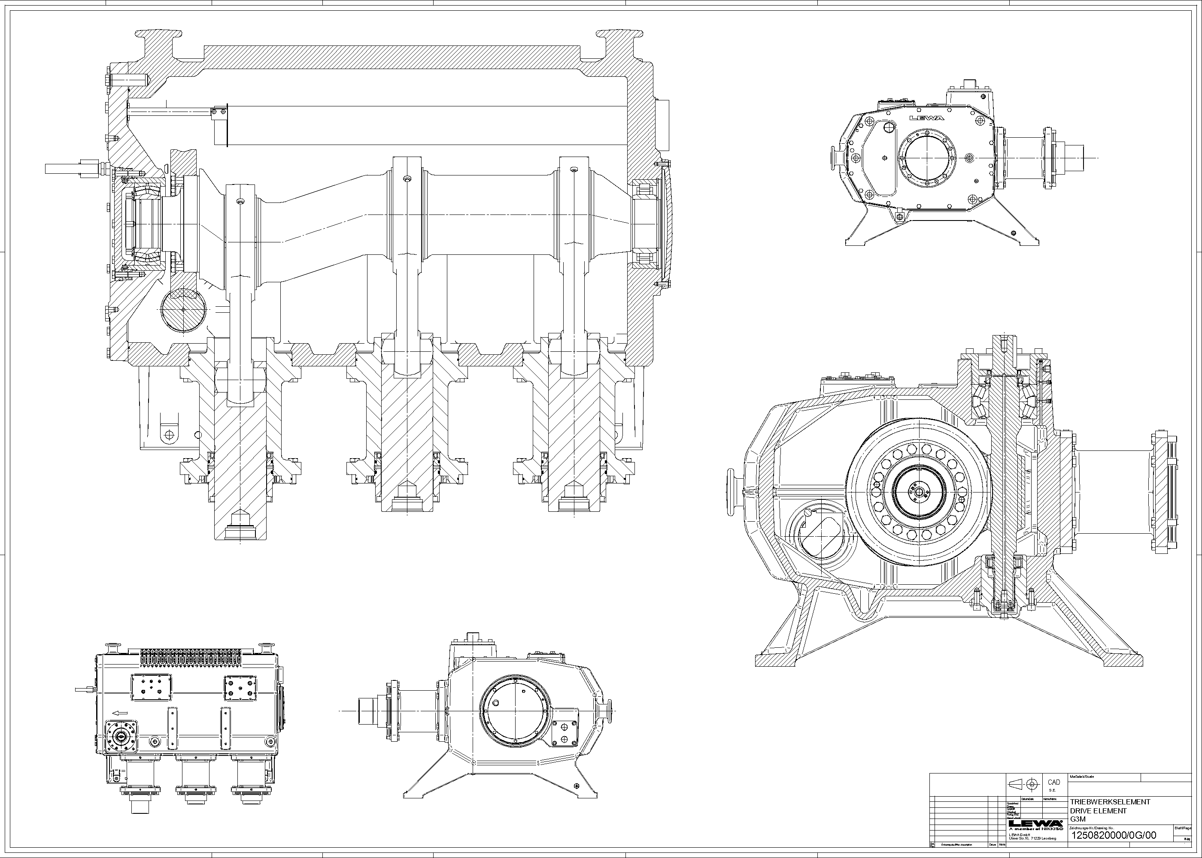
Image ID: Schnittbild_G3M_ohne_Pos.jpg
Source: Lewa GmbH

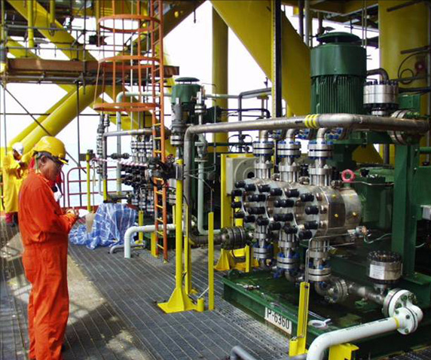
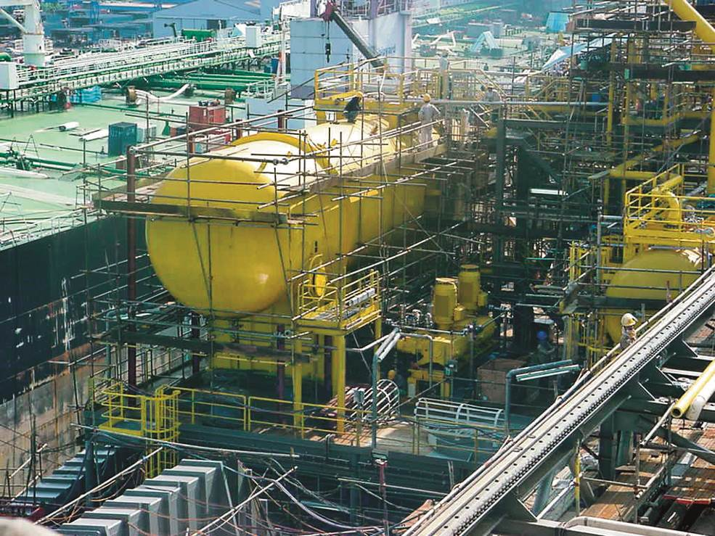
Image ID: triplex Methanol_injection.jpg und triplex_condensate injection.jpg
Caption: The G3M's sister models are used in the oil and gas industry, for example, for the injection of methanol or condensate.
Source: Lewa GmbH

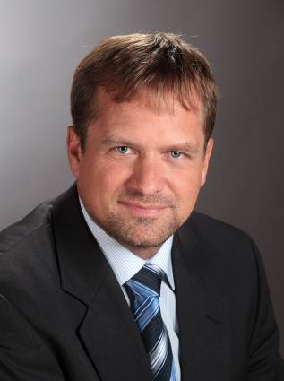
Image ID: Thomas Bökenbrink.jpg
Caption: "Cryostar has the know-how needed for working with cryogenic gases, while we supply the robust and low-maintenance technology in the newly developed drive unit that will be needed for long-term operation on board," explains Thomas Bökenbrink, product manager at Lewa.
Source: Lewa GmbH

More information for readers/visitors/interested parties:

Cryostar SAS
2, rue de l’industrie B.P 48
68220 Hésingue, France
Tel.: +33 389 702727, Fax: + 33 389 702777
E-mail: communication@cryostar.com
Internet: www.cryostar.com

LEWA GmbH
Ulmer Straße 10, 71229 Leonberg
Tel.: 07152 14-0, Fax: 07152 14-1303
E-mail: lewa@lewa.de
Internet: www.lewa.com

More information for the editors
Press agency Beatrix Gebhardt-Seele
Leonrodstraße 68, 80636 Munich
Tel.: +49 89 500315-0, Fax: 089 500315-15
E-mail: pressebuero@gebhardt-seele.de
Internet: www.gebhardt-seele.de

Reprints free of charge if the source is named; ask for a sample copy

