Preliminary trade show report from GAT (Sep. 30 to Oct. 1, 2014) in Karlsruhe/Germany
Continuous, fully automated monitoring and control of odorizing systems

For safety reasons, the Deutsche Verein des Gas- und Wasserfaches e. V. (DVGW, German Technical and Scientific Association for Gas and Water) normally requires an inspection of odorizing systems at least every four weeks. Lewa GmbH has now developed a new control system that continuously compares the set and actual values of the gas volume or odorant, so that these inspections can be eliminated or at least carried out at longer intervals. The odorant concentration can be configured in digital increments, eliminating the need for time-consuming control of the concentration by adjusting the stroke. Complete safety is retained, and remains equally high. The new OCU control (Odor Control Unit) will be presented at GAT together with Lewa odorizing systems for natural, bio, and liquid gas, and will be available starting in October.

The control system consists of one or two SPU power supplies or power packs, an OCU control unit used to control one or two solenoid-driven or motorized pumps and – depending on requirements – additional expansion assemblies. The CPU is built on a modular basis using 19" expansion cards and can be provided according to local conditions either in a 19" rack with a built-in motherboard or in a CC 7000 plastic wall housing with protection class IP66 – also with a built-in motherboard. The expansion cards for any additional inputs and outputs or special functions required, for example pertaining to filling logic, are interfaced using a plug-and-play system via the digital outputs of the SPU or via a bus.
All settings are configured in a dialog system using nine buttons, and different languages can be selected. Precision adjustment in digital steps of 0.1 µl//Nm³ or mg/Nm³ and automatic monitoring and readjustment allows odorant to be utilized optimally. The fill level is no longer measured using a probe with evaluation electronic as previously, but rather calculated based on parameterization during filling of the tank. In case of any deviations, there is a fully automatic correction in a closed control loop. The tolerance limit is ± 1 percent. Values above or below that range are reported as a fault using a red LED and in plain text on the backlit display. 200 error messages can also be stored with date and time. In case of a defective gas meter or for service purposes, the unit can be switched to "internal" mode, simulating any desired gas volume. Important operational data are not only available for registration, but can also be transmitted to the operator's control center, for example via the Lewa Netportal. The simple operation and elimination of time-consuming manual adjustment of the concentration by adjustment of the stroke reduces time requirements and ongoing costs for the operator.
In addition to the control system itself, there is another novel development that Lewa will be presenting at GAT: The pump housing and flow meter of the odorizing system on which the control system will be installed for the trade show are made of Plexiglas so that the internal moving parts of the system can be better seen. Normally, all parts in contact with fluid are fabricated of corrosion-resistant stainless steel. The layout of the system is based on applicable national and international regulations. Lewa relies very specifically on mature standard components that can be combined and extended in accordance with customer requirements. Odorizing systems can be used for many gases and gas mixtures, from natural gas to liquid gas, biogas and technical gases, and even oxygen or nitrogen. Depending on the application, magnetically, pneumatically, or electrically driven pumpes are used, with a maximum flow rate of 40 l/h and discharge pressures of up to 300 bar. In addition to their hermetic seal and precision metering, the modular design of these systems also ensures simple, safe, cost-effective operation and maintenance.
At GAT, Product Manager Walter Richter will be available for initial discussions and specific questions at Booth C 7.3 in the dm-arena.

What: GAT
When: September 30 to October 1, 2014
Where: Karlsruhe Conference Center, dm-arena, Booth C 7.3
Contact person: Walter Richter
More information: www.lewa.de

LEWA GmbH was founded in 1952 as a family company by Herbert Ott and Rudolf Schestag, and today is the world's leading manufacturer of metering and process diaphragm pumps as well as complete metering systems for process technology. The company, headquartered in Leonberg, Germany, has developed over just a few decades into an international group, and its position in the world market was further strengthened by its integration into the Japanese Nikkiso Co. Ltd. in 2009. As a researching and productive company, LEWA develops technologies and works out solutions for a wide variety of its customers' applications. Products are primarily used in the oil and gas industry, in the area of gas odorization, refineries, and petrochemistry, but also in the manufacture of plastics, detergents, and cleaning agents. Additional application areas can be found in chemistry, the cosmetics industry, in pharmaceutical and biotechnology, in the food and beverage sector, and in power supply. LEWA currently has approximately 1000 employees and has 16 subsidiaries worldwide as well as representatives and sales offices in over 80 countries.

Images:

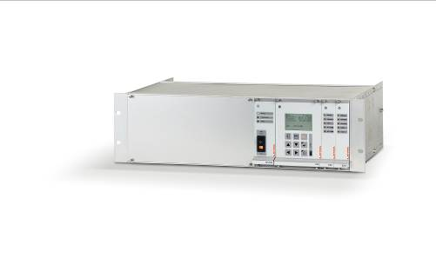
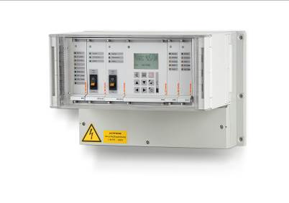
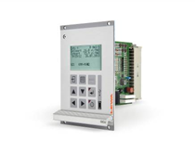
Image ID: OCU_1.jpg, OCU_19 rack.jpg and OCU_CC7000.jpg
Caption: The fully automatic OCU odor control can be provided in a 19" rack or in a wall-mounted housing.
Source: LEWA GmbH

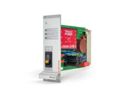
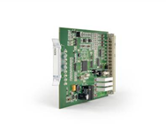
Image ID: SPU.jpg
Caption: The SPU is used as the power supply unit and magnetic-drive pump power pack unit for the control of a solenoid valve in the pressure line.
Source: LEWA GmbH

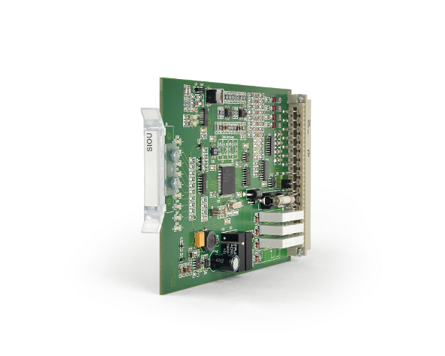
Image ID: SIOU.jpg
Caption: An SIOU extension can be installed downstream of the OCU to enable control and add additional inputs and outputs, along with special functions.
Source: LEWA GmbH

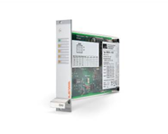
Image ID: IOU.jpg
Caption: The IOU card has its own front panel with LEDs and is used when additional inputs, outputs, and special functions are required.
Source: LEWA GmbH

Image ID: EXU.jpg
Caption: The EXU assembly also receives power from the SPU and is used for digital Ex inputs, for example from a KMM flow meter.
Source: LEWA GmbH

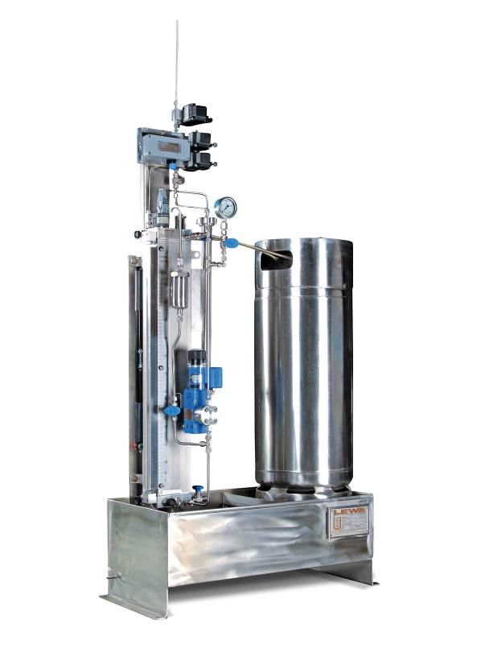
Image ID: Odorizing system.jpg
Caption: Their modular design makes Lewa odorizing systems particularly cost-effective. Depending on the application, there are stationary and interchangeable containers in sizes from 25 to 1,000 liters, and for large systems even up to 10,000 liters.
Source: LEWA GmbH

More information for readers/visitors/interested parties:

LEWA GmbH
Ulmer Straße 10, 71229 Leonberg
Tel.: +49 7152 14-0, Fax: +49 7152 14-1303
E-mail: lewa@lewa.de
Internet: www.lewa.de

More information for the editors
Press agency Beatrix Gebhardt-Seele
Leonrodstraße 68, 80636 Munich
Tel.: +49 89 500315-0, Fax: +49 89 500315-15
E-mail: pressebuero@gebhardt-seele.de
Internet: www.gebhardt-seele.de

Reprints free of charge if the source is named; ask for a sample copy

